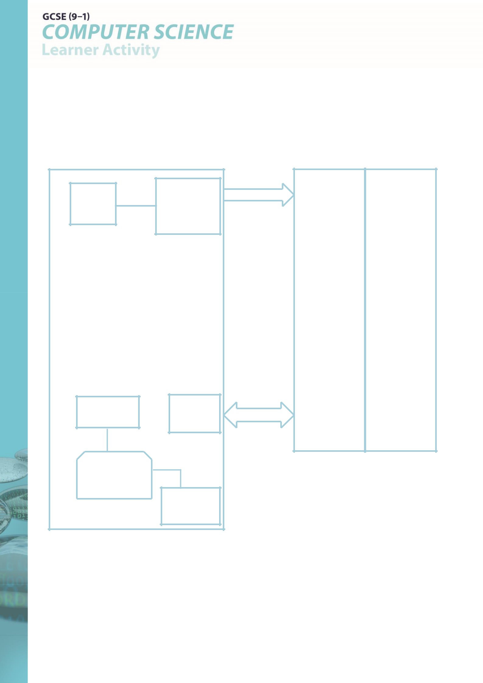

**2.1 Algorithms – L2 Activity 1**

**Diagram – Internal Components of a Computer System Medium/Low Ability task with some complete**

|  |  |  |  |
| --- | --- | --- | --- |
| Address |  |  |  |
| Bus | 0001 | INP |  |
| MAR | 0010 | Add 5 |  |
|  |  |  |
|  | 0011 | INP |  |
|  | 0100 | STO 8 |  |
|  | 0101 | INP |  |
|  | 0110 | ADD 8 |  |
|  | 0111 |  |  |
|  | 1000 |  |  |
|  | 1001 |  |  |
|  | 1010 |  |  |
|  | 1011 |  |  |
|  | 1100 |  |  |
|  | 1101 |  |  |
| ALU |  |  |  |



1. Find definitions of the following

|  |  |  |
| --- | --- | --- |
| **Processor** | Performs calculations in the computer – Executes Instructions |  |
|  |  |

**MAR**

**MDR**

The CIR is the Current Instruction Register. This hold the

**CIR** instruction that has just been fetched from main memory and is about to be executed.

**Main Memory**

**Address Bus**

**Data Bus**

**Accumulator**



|  |  |
| --- | --- |
| **PC (Program Counter)** |  |
|  |  |
|  | Arithmetic Logic Unit – performs arithmetic (Add / Subtract) and |
| **ALU** | logical (AND, OR) operations |
|  |  |